REQUIREMENT ANALYSIS

MODULE 4 – Technical Stack
Date : | 27.09.2026
Team ID : | SWTID-2026-9496
Project Name : | Streamlining IT Procurement: Automating Standard Laptop Orders with Flow Designer
Maximum Marks | 4 Marks

Technical Architecture
Layer 1: User Interface
- ServiceNow Service Catalog
- Standard Laptop Catalog Item
- Requested Item Form
- Catalog Task Form
Layer 2: Request & Approval Logic
- Standard Laptop Request
- Requested Item
- Approval Process
- Approval Status
Layer 3: Automation & Processing Logic
- Flow Designer
- Standard Laptop Task Flow
- Create Catalog Task Action
- Assignment Group Configuration
Layer 4: Infrastructure
- ServiceNow Cloud Instance
- Personal Developer Instance (PDI)
- Web Browser
Layer 5: Data Storage
- Service Catalog Item
- Requested Item Records
- Catalog Task Records
- Approval Records
Layer 6: User / Team Processing
- Requester
- IT Procurement Staff
- Hardware Assignment Group
- Hardware Team

Technology Stack Components
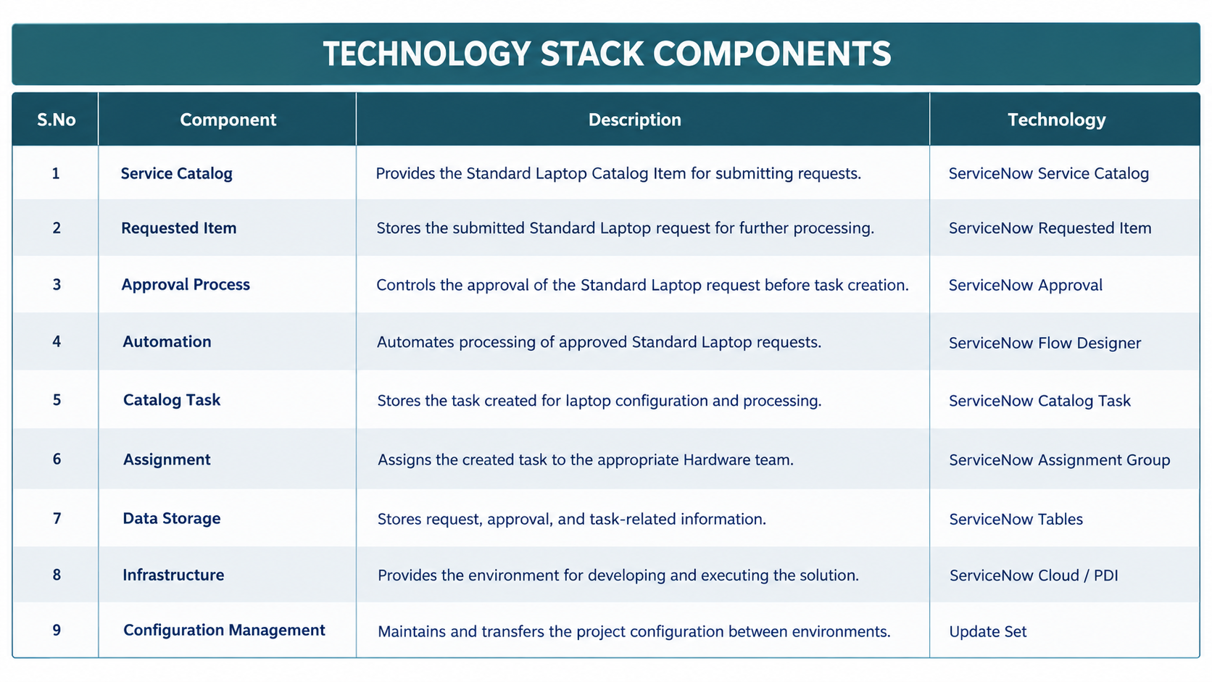

Platform

ServiceNow
ServiceNow is used as the main platform for creating and managing the Standard Laptop procurement request, approval, Catalog Task, and assignment process.

Automation Tool

Flow Designer
Flow Designer is used to automate the Standard Laptop procurement process. It processes the approved request and automatically creates the required Catalog Task and assigns it to the Hardware Assignment Group.
This directly matches the reference's use of Flow Designer as the main automation component, while adapting the purpose to your project.

Data Storage
ServiceNow Tables
ServiceNow tables are used to store the information related to the Standard Laptop procurement process, including:
- Catalog Item
- Requested Item
- Approval information
- Catalog Task
- Assignment Group
- Task Status

Configuration

ServiceNow Catalog & Flow Configuration
The Standard Laptop Catalog Item, approval process, Flow Designer flow, Catalog Task details, and Hardware Assignment Group are configured within ServiceNow.
The Standard Laptop Task flow is associated with the Standard Laptop Catalog Item to automate the required task-processing workflow.
Deployment & Maintenance

Update Set
An Update Set can be used to maintain the ServiceNow project configuration and transfer the developed configuration between ServiceNow environments.
The reference also identifies Update Set as the mechanism for configuration management and deployment.

